1. **To view the table**

select * from pizza_sales;

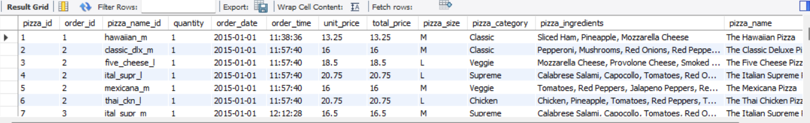

1. **to check total revenue**

select sum(total_price) as Total_Revenue from pizza_sales;

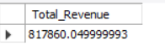

1. **Average order value**

select sum(total_price)/count(distinct order_id) as Avg_Order_Value from pizza_sales;



1. **total pizzas sold**

select sum(quantity) as Total_Pizzas_Sold from pizza_sales;



1. **total distinct orders**

select count(distinct order_id) as Total_Orders from pizza_sales;



1. **avg pizzas per order**

select cast(cast(sum(quantity) as decimal(10,2))/

cast(count(distinct order_id) as decimal(10,2)) as decimal(10,2)) as Avg_Pizzas_Per_Order from pizza_sales;



1. **Total orders each day of the week**

select dayname(order_date) as Order_day, count(distinct order_id) as Total_orders

from pizza_sales

group by Order_day ;

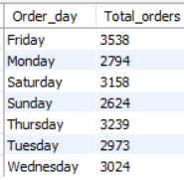

1. **To change order-date from string to date**

alter table pizza_sales

modify column order_date date;

1. **Total orders each month**

select monthname(order_date) as Order_month, count(distinct order_id) as Total_orders

from pizza_sales

group by Order_month

order by Total_orders desc;

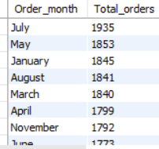

1. **Category wise sales margin**

select pizza_category, sum(total_price)*100 / (select sum(total_price) from pizza_sales) as Total_sales from pizza_sales

group by pizza_category;

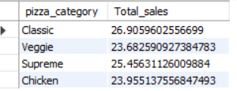

1. **Pizza size wise sales margin**

select pizza_size, sum(total_price)*100 / (select sum(total_price) from pizza_sales) as Total_sales from pizza_sales

group by pizza_size;

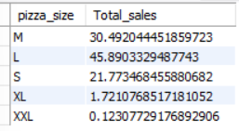

1. **Top 5 pizzas with highest revenue**

select pizza_name, sum(total_price) as Total_Revenue

from pizza_sales

group by pizza_name

order by Total_Revenue desc limit 5;

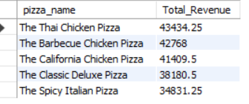

1. **Top 5 pizzas with lowest revenue**

select pizza_name, sum(total_price) as Total_Revenue

from pizza_sales

group by pizza_name

order by Total_Revenue asc limit 5;

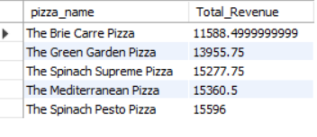

1. **Top 5 pizzas with highest ordered quantities**

select pizza_name, sum(quantity) as Total_quantity

from pizza_sales

group by pizza_name

order by Total_quantity desc limit 5;

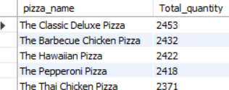

1. **Top 5 pizzas with lowest ordered quantities**

select pizza_name, sum(quantity) as Total_quantity

from pizza_sales

group by pizza_name

order by Total_quantity asc limit 5;

